There are tow types of revision ranges
1. Double dot revision range
2.

first switch to brach that need to merge
> git switch master
then merge
> git merge license

fast forward merge
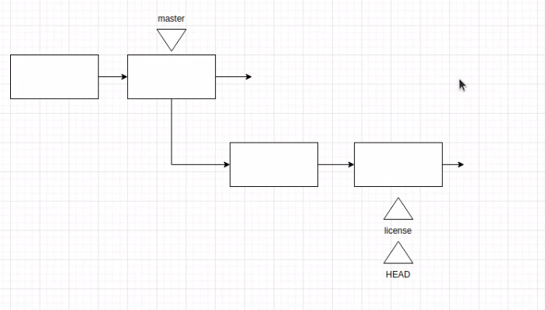

normally after merging a brach to master, remove that brach

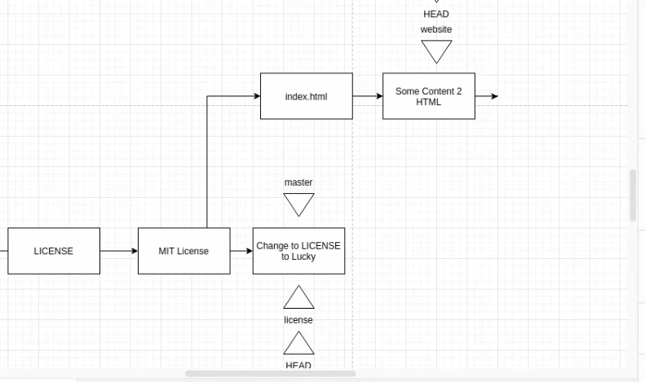

fast forwarding merge cannot be done for this, because there is a barrier
need to do recursive merge
Recursive merge

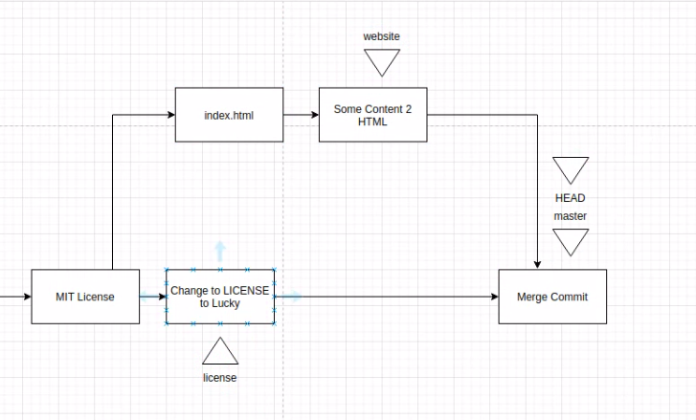

use > git log –oneline –all –graph every time

Fast forwaring merge | Recursive merge
No conflicts | May have conflicts
 | Show in commit history with time
see which brances are merged
> git brach –merged

which branches that not merged
> git branch –no-merged

do recursive merge forcefully
> git merge –no-ff mange-customers

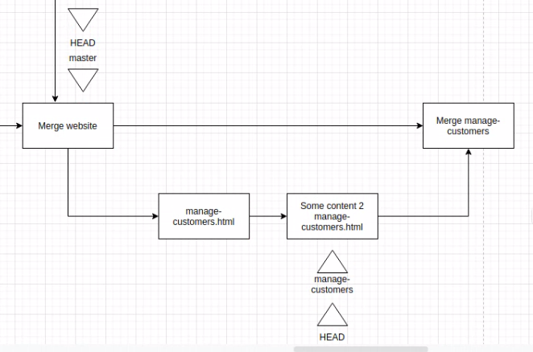

make a request-→ don’t complete merge process (merge completed, but not mention in history)
> git merge –no-ff –no-commit manage-items

commit will be done by me after doing some more works

3 – way merging

which one select for final result,

cancel the merge
> git merge –abort

continue merge after resolve
> git merge –continue

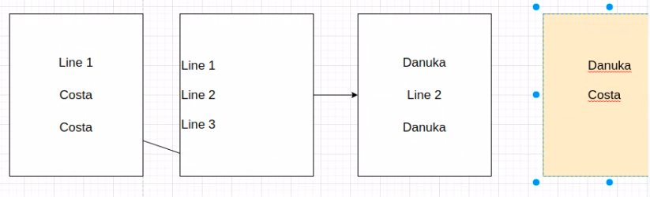
to see the conflicts that didnt resolve with commits
> git log –merge

to see all the merges
> git log --merges

